TOGETHER FOR THE STUDENTS!

APPLICATIONS FOR PRESIDENT AND OFFICIALS

EÖTVÖS LORÁND UNIVERSITY OF SCIENCES FACULTY OF SOCIAL SCIENCES STUDENTS’ UNION 2023/24

„Be the change you wish to see in the world.” – Mahatma Gandhi

President and officers’ application
2023/24

Tartalom

Vasas Máté – Candidate for President 3
Bálint Izabell – Candidate for Vice-President 10
Balogh Fanni- Candidate for Social Vice-President 14
Bényei Tamás – Candidate for Academic Vice-President 16
Pikó Balázs Lajos -Candidate for Vice-President of Economics 18
Closing words 20

Vasas Máté – Candidate for President

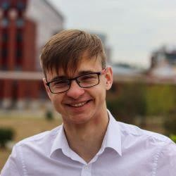
Introduction

I am Máté Vasas, a second year student of International Studies at ELTE TáTK. I was born in Kisvárda in 2002, where I finished primary school and high school at the Bessenyei György Gymnasium and College, and then I was admitted to ELTE in 2020.

Experience

Although high school advocacy work is not comparable to university, as a class secretary in high school I got a taste of what it's like to be responsible for several people at once, to get the right information across and to work constructively together to achieve good results both inside and outside the institution. Building on these foundations, from May 2021 I held the position of Academic and Legal Affairs Officer at the ELTE TÁTK Students’ Union (HÖK) until the end of April 2022. I was then elected President of the HÖK. During the last 2 years I have gained a lot of experience, I have learnt about the dynamics of the university, I have become familiar with the legislation in force, I have learned the ins and outs of team leadership. I have developed, made mistakes, stood up, worked

Motivation

The last year alone can be described as a reason for my lack of motivation. I am surrounded by the best people, I want to represent the best people, in the best community. These three years have confirmed my belief that the individual cannot fulfil himself, but that belonging to a community and the group experience are his virtues. To live this idea, I joined the

mentor training 3 years ago, joined the Students’ Union 2 years ago, ran for President 1 year ago and am now running again, more motivated than ever. I will work to continue to represent the spirit of the TÁTK (Social Sciences Faculty) with a 'true TáTK slogen accept and includive' mentality, I want to pass on and reinforce the core values that I have received from ELTE, TÁTK, the HÖK and the people around me.

GOALS

Transparency

Every organisation seeks to build trust with the people it works for. An excellent way to do this is to increase transparency, to show how the organisation works and what is being done within it. It is the responsibility of the PSI to demonstrate and maintain the level of transparency that all students deserve. The website will play a major role in fulfilling this duty. As part of this programme, I would also like to encourage everyone to get to know the PSI, one of the best ways to do this is to attend the open board meetings that will be announced at a later date. We would also like to organise a HÖK Day, where students can meet people working within the organisation and see what is going on - thus increasing openness.

Openness

The HÖK should be open to new ideas, challenges and opportunities. As a stakeholder organisation, we provide an atmosphere where we listen to the voice of individuals; where everyone's opinion counts. That is why we ourselves must also be open. What do I mean by that? I mean that we must be as open to the ideas of the students we represent as we are

to the voices within the HÖK. But we must also be open to the proposals of the Students' Union, to the ideas of the Dean’s and Rector’s. We must also be open to suggestions not only from within the institution but also from outside. Without teamwork, cohesion and solidarity, even the most talented cannot achieve their own or common objectives. We are no exception. We need to be open so that others can open up. This is a core value of the TáTK and of ELTE as a whole, which we have a duty to pass on and which is the basis of all cooperation.

Events

The importance of events lies in their ability to bring people together. New people, new ideas, new ways of looking at the world - each one a different story. These stories come together at events and a new one can be written. As well as music and dance being one of the best ways to bring people together, I think it's important to have events that require mental and physical effort. In addition, with the help of the expertise and competence of the Events Committee, various faculty and all-UNESCO events and music and dance parties will be organised, with the relevant information and dates to be published on the renewed website, and the SzHÉK will be given more scope to organise departmental events in addition to the Events Committee.

Website

The current website is well put together in terms of functionality, but needs a little refreshing for greater transparency and access to the right information in the right place, as well as for ease of use. The use of a News for Students - Student - Student - Scholarship - Life - Culture - Equal Opportunities - Transparency menu would also help to achieve this better transparency. Pictures of various events will be brought back. We also want to put more emphasis on the display of news updates. It is important that foreign students feel involved and aware of news that is happening inside and outside the university, so I would also like to see the website translated into English. Our aim is to increase the number of

visitors to the site in order to inform students as accurately as possible and to give them a clearer view of the organisation itself.

Cooperation - relations

We are all collaborative, we all like to cooperate with others. It's always a pleasure to organise events in partnership with other faculties and to implement them together. We would like to continue this habit in the future, and we are happy to continue working with other faculties to organise various events. Furthermore, trans-institutional events should not be excluded, as they can also play a role in building new relationships. These collaborations provide an opportunity to get to know each other and different traditions and to learn new practices. In addition to this, I would like to give priority to cooperation with the faculties on the Lágymányos campus (TTK, IK), given that we share the same buildings and are also a team in the organisation of LEN. With the individuals and organisations listed in the previous point, mutual respect, communication, and the willingness to compromise and develop together are also the goals to be kept in mind. These are the key concepts that describe the basis of our relationships. The possibilities are endless, we just have to use them.

Organisational development

Over the past 2 years, I have managed to develop a more comprehensive picture of the organisation's workings. It's easier to see how processes work, to climb the steps, to identify obstacles. There is no shortage of conclusions, which should be given space in the next year. The aim and task of the HÖK is to solve the problems that arise. At the moment, these are all ad hoc, processes are not mapped out, officers' responsibilities are not fully defined, there is no evaluation. They would like to frame these in the next year, to close operational gaps and make the organisation more efficient.

Amedment of statue

The current statute was amended almost half a decade ago. But in the period since then, changes have accelerated rather than slowed. These changes are not reflected in the current

Statute, parts of which are outdated and others of which are an obstacle to organisational efficiency. Reviewing and changing this will be one of my main objectives for the coming year.

Office

The office is the lifeblood of the life and work of the HÖK. It is the place where students meet most often with their fellow students. However, in the last two years, the office as a point of origin has essentially ceased to exist, students - especially those arriving from 2020 - don't know where the office is, many don't know anything about the HÖK, and many don't know anything about the university buildings (I myself saw a lecture theatre full of life for the first time in March) because of the online format. As I mentioned before, it is very important to bring the university feeling back into the lives of students. The Student Union office has a big role to play in this. In addition to the fridge and the microwave, the Students’ Union Offices are on call two hours a week: we will put this on the website, so that if someone has a specific question, they can ask for help not only online. I aim to re-map the outside of the office and put up different signage to make it easier to find the office. I also aim to purchase a projector that students can 'borrow', and to keep personal valuables for a game of foosball.

Delegates Assembly

The Delegates' Assembly is one of the most important roles in the functioning of the HÖK. As the main decision-making body, the members of the HÖK are accountable to this body, alongside the students, and it is the body that holds the members to account and ensures that the organisation functions properly. For this reason, I also consider it appropriate to expand the number of members, based on the principle of more eyes seeing more, and I consider it important to involve students who are ready to take action, both from undergraduate and postgraduate courses. I would also like to take this opportunity to invite all students of the Faculty of Fine Arts who are willing to take action to apply to become a delegate! It is important that our work is based on discussing issues that affect the university, and the Assembly of Delegates is the perfect forum for this. With the hopefully "grounding" of attendance education, the Delegates' Assembly will once again be a priority, and I

encourage everyone to attend Delegates' Assemblies in person. This is the basis for the functioning of any democratic organisation, where students' ideas come forward.

Students’ ideas

One of my goals is to create a forum where students can express their views on the functioning of both the Students’ Union and the Faculty, where they can say how satisfied they are and how represented they feel. There will also be a special section in this forum where students can express what they would like to change, what kind of event they would like to organise. This would be the place where students would have the opportunity to express their own opinions, so that they can be presented to those working in the HÖK. In this way we could discuss whether changes are needed and, if so, how to implement them. However, I would like to avoid creating an endlessly boring questionnaire, because on the one hand everyone is bored with it, and on the other hand it does not fulfil its role, given that not many people fill it in. The aim here is also to show the students that they are part of a community, that they are represented, that their opinions matter and that, above all, things are happening for them. New applications and competitions will be excellent examples of this.

Applications, competitions
I believe it is important that the knowledge acquired is not only theoretical but also of practical use. With this in mind, I would like to create more intra-faculty competitions for which both undergraduate and master's students, Hungarian and foreign, can apply. I would like to be included in these applications and competitions:
- Essay competition
- Photography competition
- Foosball competition
- Video competition

In addition to these, other competitions are planned and more information will be made available as details become available.

Foreign Students

I think it is very important to involve foreign students more widely, both at the decision-making level and at the level of events. We are all part of the TáTK, and our opinions count equally, because we are the foundation of this community, we shape it and we bring it to life. This is also the purpose of the English version of this competition, which will give foreign students a clearer idea of my vision.

Szombathely

The relationship with our faculty's branch in Szombathely is also an important point of contact for the community. I would like to strengthen this relationship with at least two "Szombathely meetings" per semester, which would mean two trips to Szombathely per semester. We would also like to welcome students from Szombathely to the Lágymányos Campus for various events.

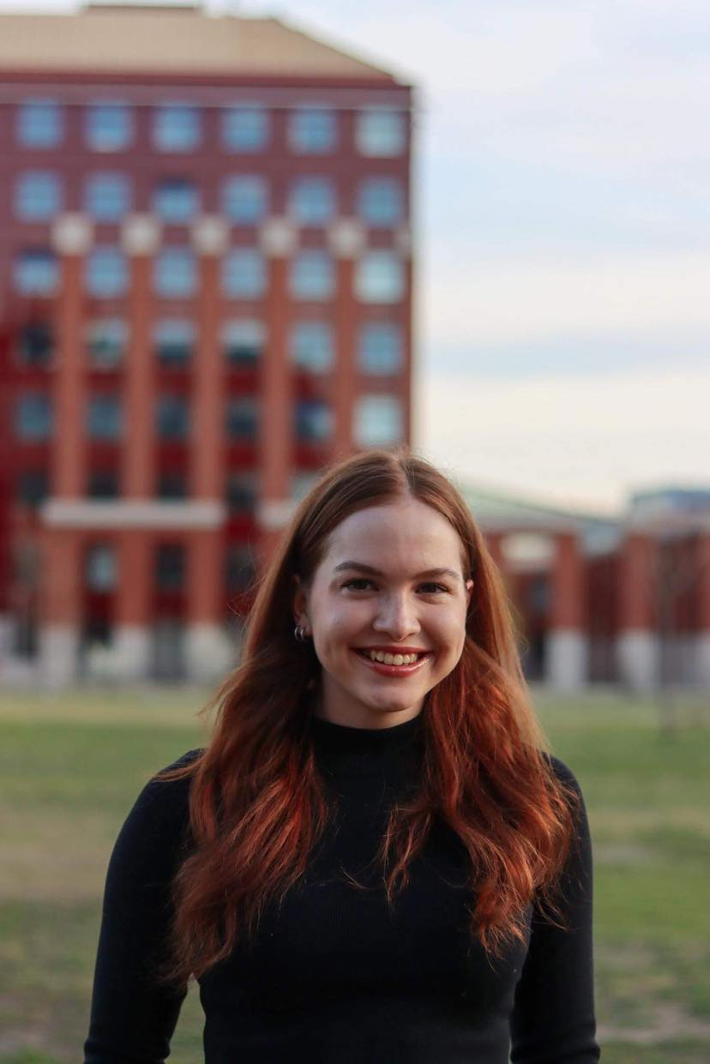
Bálint Izabell – Candidate for Vice-President

Introduction

I am Izabell Bálint, a second-year student of the Faculty of Social Sciences at ELTE, studying International Studies in English. During my almost four semesters here so far, I have experienced the values and the spirit that the TáTK community values: acceptance and inclusion, a great atmosphere and an outstanding intellectual environment. Over the past year, I have been involved in the work of the student government, which has helped me to get to know the students of our faculty even better and made it an even more important goal of mine to contribute to the life of the community in some way. I look forward to doing this in the near future through the responsibilities of a new position.

Experience

A year ago, in the spring of 2022, I was elected to the student government of our faculty when I applied for the position of Chairman of the Events Committee. I have held this position for the past year and it is perhaps no exaggeration to say that I have had one of the most influential periods of my life. Event management has given me insight into new areas of operation and knowledge that I had not had the opportunity to acquire before. I have had the opportunity to work with many people (both inside and outside our organisation), all of whom have taught me a great deal, both professionally and in terms of human values. Over the past year, I have also become more and more familiar with the way our faculty's organisation works, observing from the inside in a sense, as I myself have been carrying out my duties within this structure. I think that I would be able to channel these insights into my duties as Vice-Chair, so that I would have the added value of having had the opportunity to experience student representation from a different perspective.

All in all, I am confident that the experiences, lessons learned, successes and failures of my activities so far will all contribute to my ability to carry out my duties and achieve our goals as effectively as possible when I take up the position of Vice-President..

GOALS
Coordination and development of organisational operations

During the past year I have had the opportunity to observe the functioning of our student government at both committee and higher levels. I have gained an overview of the work of the different sections and, as committee chair, I have experienced how it is possible to be both responsible for the tasks delegated to me and coordinate the work of the officers working with me. One of my main objectives is to bring the organisation closer together and improve its functioning, as I believe that without proper team cohesion we cannot develop. I believe it is important to assess our strengths and weaknesses and to reflect on them in order to develop a forward-looking strategy. I would like the committees to be able to work in less isolation, with more coordination between the different areas, so that we can be as effective as possible, helping each other. To do this, I believe that we need to strengthen the formal framework and to plan consciously.

Awareness of the organisational structure
I think one of the cornerstones of the above-mentioned ambition is to raise awareness of the organisational structure. I think it is important for officers to be aware of exactly how their work is integrated into the functioning of the organisation, with whom they should be in constant communication in order to be able to carry out their tasks as smoothly as possible. In recent years, our student government has continued to evolve and expand, as new projects and changing circumstances have brought new tasks that have required more

people to work in certain areas than before. However, this development goes hand in hand with challenges such as rethinking the division of labour, defining the responsibilities of new officers or integrating their positions into the existing organisational structure. I would like to continue this process, which has already begun, by defining the precise roles and responsibilities of each committee and officer, and by developing an operational framework that will make the work of our team as efficient as possible.

HÖK position reproduction-system

One of the challenges that every presidency faces from time to time is the issue of succession. In my experience, it is often difficult to find the best candidate for a particular position, as a position involves many different responsibilities and therefore requires many different skills. The selection process is also made more difficult by the fact that these competences are often difficult to measure, so it is better to base the decision on the candidate's overall personal and professional qualities. I think it is important to provide a framework for the issue of succession, even though, as I have already mentioned, very different selection processes may be appropriate for different posts. I think that it would be worth documenting the succession process so that, in time, each post would have a well-established selection process based on experience. As this is a problem that affects all student governments, I would find it useful to consult with other faculties on this issue, comparing different practices, as I believe that the opportunity provided by the student representative community to inspire each other, share experiences and learn from each other is one of the greatest assets we have as citizens and faculty representatives of ELTE.

Faculty identity

I think that the issue of faculty identity is in a sense undervalued, because everyone experiences it and knows about it, but we don't use it with enough awareness. Every student is aware of his or her own faculty, of the values that are at the heart of the community and of what binds him or her to his or her fellow students. This is reflected in the motto of the TáTK: TáTK accepts and include. In the past year, when organising various events, I wondered why it was that some programmes attracted more students than expected, while others were far below our expectations. In my opinion, one of the factors here is faculty

idea, which at first sight seems elusive and malleable, but in such situations becomes very tangible. So I think it is important to recognise what the values are that students in our faculty prioritise and not only to build on this in certain issues (to serve student needs as much as possible), but also to do something to reinforce this, deepening the sense of belonging.

Development of an evaluation system

One of the first ideas I had when thinking about the points of my application was to develop an evaluation system both inside and outside the student government. Working in a team is often not easy, and the quality of joint work can be compromised at many points, one of the most important of which is the issue of feedback and evaluation. I think it is essential for long-term sustainable teamwork that we have the opportunity to give feedback to each other and to evaluate our joint functioning. This practice is currently in place in our team, I would only change it by making it systematic. I would like to provide an opportunity for individual officers and committees to give feedback and evaluate their own work, each other's work and the work of the chair, vice-chairs and vice-chair (with two-way communication of course, as mutuality is the cornerstone of working together) in an organised way at regular intervals. I would do all this in a documented way so that the trajectory of progress can be tracked. In addition, I would like to introduce a system whereby we could also assess the needs of students through questionnaires and give them a platform to share their views on the work of the student government, since ultimately it is their representation that we are responsible for.

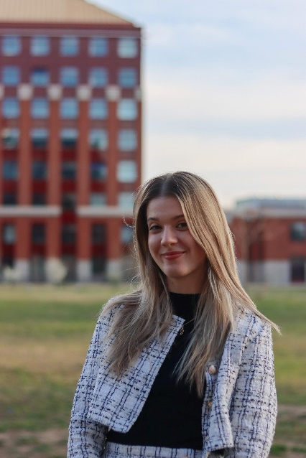

Balogh Fanni- Candidate for Social Vice-President

Introduction

I am Fanni Balogh, a second year student of the Faculty of Social Sciences at Eötvös Loránd University, majoring in International Studies. I have been a member of the HÖK since my first year as the Member in charge of Dormitory Affairs, and now I have the honour to be asked to be the Social Vice President. Over the years I have had the opportunity to familiarize myself with the position, so I hope to be able to offer the best and the best to the Students.

Motivation

Our world is not exactly free of hustle and bustle. Living, working and having a social life at university puts a strain on many students, so I want to create a space where anyone can dare to ask for help with confidence and without fear. An educational institution should be a place that supports and helps Students in all aspects of life. I want to show that with joint cooperation and support, problems can be solved.

Affairs, tasks
One of my tasks is to facilitate students' applications for social grants, as many of them depend on it for their livelihoods. I would like to do this by creating a Social Support Know-How, which will help applicants in detail and with example documents.
I also want to develop mental hygiene in our faculty. In addition, I aim to contact different life coaches who could help the Students in an open discussion and give them a start in solving their problems.

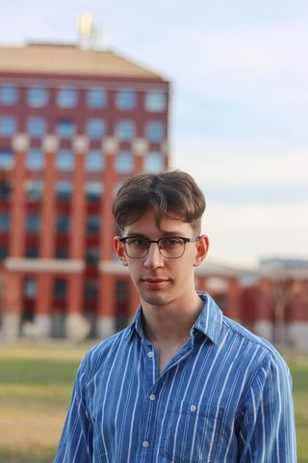

Bényei Tamás – Candidate for Academic Vice-President

Introduction

I am Tamás Bényei, a second year sociology student. Since I have had the opportunity, I have always tried to participate in student advocacy in my educational institutions. I have served as vice president of both the primary and secondary school student councils for many years. I have therefore made it my goal to hold a similar position in the student body of my university, knowing that it will involve responsibilities unlike any I have held before.
So when Máté Vasas, current President and candidate for the next term, asked me in spring 2022 to succeed Levente Bibor, who was stepping down at the time, as Vice President for Studies of the TáTK HÖK, I was delighted to accept the opportunity.

Motivation

The past year has been an extremely rewarding experience as Vice President for Studies. At the beginning, I usually encountered obstacles in the course of my varied work, but over time I have learned to perform my duties properly.
Still, I believe that there is always room for improvement and that it is always worthwhile. I often feel that it is not enough for the Vice President for Studies to simply follow the points in the statutes that apply to him or her, but that it is almost a duty to give something extra. With a certain self-criticism, I can say that I have not been able to give that extra, and that is why I am sufficiently motivated to look forward to another term to prove that I can give that extra.
After all, the student government is for the students, and students come to university first and foremost to study, and only secondly for the social experience. Therefore, it can perhaps be said that the Vice President for Student Affairs is one of the most responsible positions in student government. With this in mind, if elected, I will strive to perform my duties with maximum dedication.

Objectives

From my experience over the past year, I have identified two study topics where it would be of paramount importance to improve communication with students.
The first is the methodology for calculating study grants. A very large percentage of students are not aware of the system by which the amount (or even the existence) of their scholarship is determined. I will pay particular attention to addressing this problem in the 2023/24/1 semester, when the fall scholarships will be awarded. I am determined to communicate to each and every student in the faculty how the scholarship is determined.
Another recurring problem is the process of writing the thesis. It is true that students are officially informed about this, but I know from feedback and messages in the departmental chat groups that doubts regularly arise. To address this, in September I intend to work with the Presidents of the Specialist Student Interest Groups to extend the thesis information session for third-year sociology students, which is already held in September, to all three undergraduate courses and to all three years of the undergraduate courses - after all, you can't start to get informed early enough.
If I am elected, I would like to increase the frequency of meetings with the supervisors in the coming term, so that we can brainstorm together on how to improve student life, exchange views on the problems affecting students and, of course, find solutions to them.
I will also try to boost academic life, as the number of students participating in the TDK is decreasing every year, and the number of students attending professional programmes and workshops organised by university lecturers is also decreasing. As a university, I think that ELTE's teachers are doing a very high level of academic work and its students are receptive to this work, but we just need to promote the programmes to a wider audience.

Pikó Balázs Lajos -Candidate for Vice-President of Economics

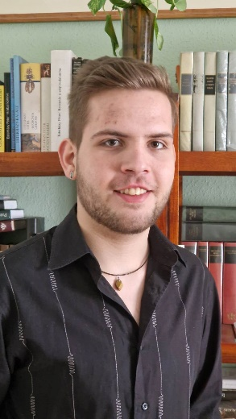
Introduction

I am Balázs Lajos Pikó, a first-year student of Sociology at the Faculty of Social Sciences of ELTE. I have been a member of the Sociology Section for almost a year now, through which I got to know the workings of the Student Union, its society and we organized some very enjoyable programs, and I also got to be a part of the mentoring program of the 2023 freshman camp. At the invitation of the current President and President Candidate Máté Vasas, I would like to be the Vice President for Economics of the Student Union for the academic year 2023/24.

Experience and Motivation

I have always been interested and attracted by the organisation of life in a community, whether it is programmes or solving problems and conflicts within the community. My goal has always been to make sure that no one feels left out or excluded, because I think that's the only way we can get the most out of ourselves as a community. Even in high school, I organised programmes and exhibitions on many topics of interest or concern to the community. As I mentioned above, since my first semester I have been a member of the Sociology Section, where I have met a lot of people and become part of a productive society. I have also had the opportunity to gain insight and knowledge about the functioning of the HÖK. These experiences and lessons have inspired me to continue the work and activities I have started this year in a more responsible and confidential position.

Tasks and cases

If the Delegates' Assembly finds me suitable for the position, I will be responsible for supporting the Students' Union and the students in all economic and financial aspects that I have insight into. My task will be to prepare the annual budget in a way that is beneficial and useful to all students and to have it approved. My aim is to ensure that the budget and costs of the DGB are transparent and representative of the needs and interests of our students. Of course, I am also responsible for providing the financial backing for fun, educational or professional events for students. I would like to carry out a needs assessment so that we really have events that are in the interests of our students. In a sentence, I feel that my task and my cause and my aim is to represent the interests and meet the needs of our students within the scope of my duties.

Closing words
Dear Reader!
First of all, I would like to thank you for taking the time and energy to read this application. If we are elected, we will work with all our energies to implement the points mentioned above and many more. If the members of the Delegates' Assembly consider us suitable to take up our posts, I would like to ask for your kind support! We will do it together, for you.

Vasas Máté
Bálint Izabell
Pikó Balázs Lajos
Balogh Fanni
Bényei Tamás

Pictures:
own, elte.hu

Kisvárda, 2023.04.07.

